4.4, 4.5 TEST MS
1. (a) Observation orange or red-brown precipitate (1)
Structure
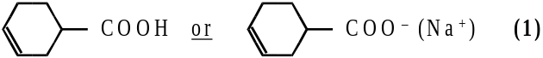 2
(b) Equation RCHO + HCN → RCH(OH)CN (1)
Type of reaction nucleophilic addition (1)
Mechanism
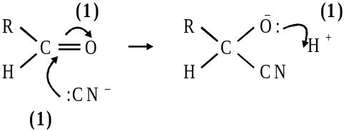 5
(c) Type of isomerism optical (1)
Structural feature atom with 4 different substituents
or asymmetric or chiral (1)
Isomer 1 Isomer 2
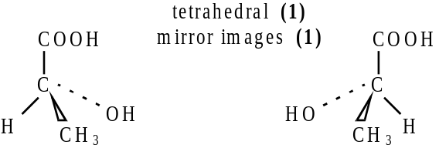
Method of distinguishing opposite rotation of polaroid light (1) 5
[12]

2. (a) propyl methanoate; 1
HCOOC3H7 + OH– → HCOO– + C3H7OH
OR
HCOOC3H7 + NaOH → HCOONa + C3H7OH; 1
(b) (i)
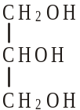 1
propan(e)-1,2,3-triol
OR
1,2,3-propan(e)triol
OR
Glycerol; 1

(ii) CH3(CH2)16COONa or C17H35COONa or C18H35O2Na; 1
(ignore 3 in front of formula but not if indicating trimer)
(not just anion and penalise Na shown as covalently bonded) soap -
allow with detergent but not detergent alone; 1
[6]

3. (a) Structure of P: 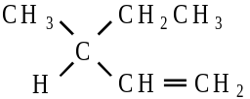 (1) 3
Structures of Q and R: 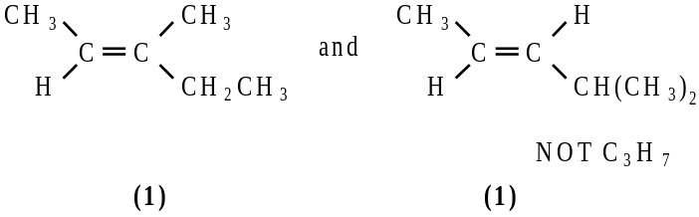
Q and R in any order
(b) (i) Racemic mixture: equal mixture of optical isomers / enantiomers
OR in explanation
Explanation: planar ( >C=O) (1)
attack from either side is equally likely (1)
(ii) Reagent S: HCN or (KCN / HCl or H2SO4) (1)
Compound T: 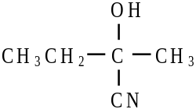 (1)
Compound U: 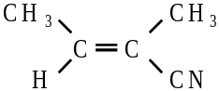 (1) 6
[9]

4. (a) graphical structure for CH3CH2COOH (1)
allow CH3CH2– or C2H5– 1
(b) (i) ethanol / CH3CH2OH / C2H5OH not just alcohol (1)
(concentrated or dilute) sulphuric acid / HCl / strong acid / H+
not just acid solution
heat / reflux / warm / temperature < 100 °C (1)
allow second and third marks if alcohol given
third mark is dependent on first and second marks
second mark is independent on first mark 3
(ii) ethyl propanoate (1) 1
(iii) CH3CH2COOH + CH3CH2OH → CH3CH2COOCH2CH3 + H2O
C3H6O2 + C2H6O → C5H10O2 + H2O (minimum for mark) (1)
CH3CH2COOCH2CH3 or C2H5CO2C2H5 (1) 2
(c) (i) compounds with the same molecular formula /
same numbers of same atoms (1)
but different structural formulae / structures or (1)
atoms joined / bonded / linked in different orders / C skeletons
not atoms arranged differently 2
(ii) sodium ethanoate / CH3COONa (1)
propan-1-ol / CH3CH2CH2OH / propanol / propan-2-ol (1) 2
[11]

5. (a)
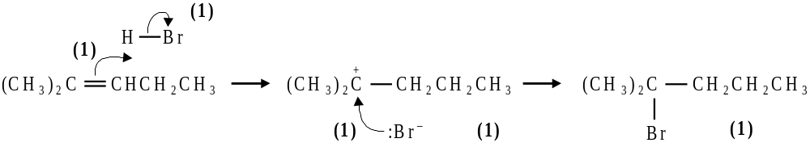
2–bromo–2–methylpentane (1)
tertiary carbonium ion more stable than secondary (1) 7
(b) geometrical or cis–trans isomerisation (1)
hex–3–ene or hex–2–ene (1)
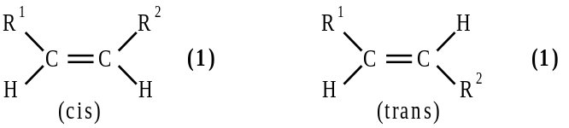 4

(c) optical (1) 3–methylpent–1–ene (1)
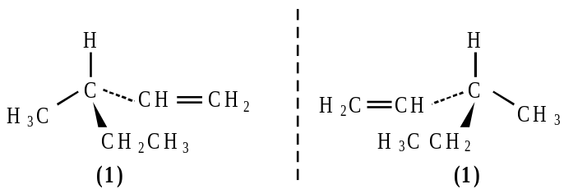 4
[15]

